**Client PC Reporting Tool** v1.0

This tool will help platform engineer troubleshooting end user machine by providing system status, remotely gather logs and registry information. Pre-requisite for using the tool is PE should be able to access remote machines with ad_username account.

Path to Tool: \\itcbdropbox.intel.com\dropbox\PlatformEng-KT-Resources\User\abraham\Tools\Client PC Reporting Tool.exe

1. Copy the Tool to c:\temp location and run with ad_username account.
2. Press SHIFT and right click tool.
3. Select run as different user.
4. 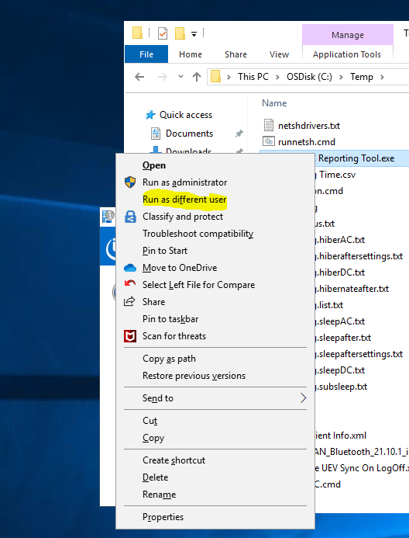
5. You will see below UI prompt.

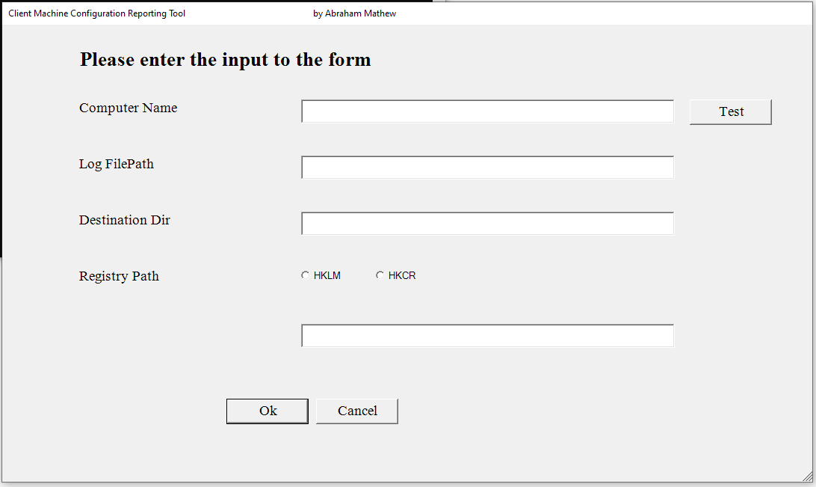

1. Enter computer info and click on Test button to check the status of remote computer.
2. If computer online

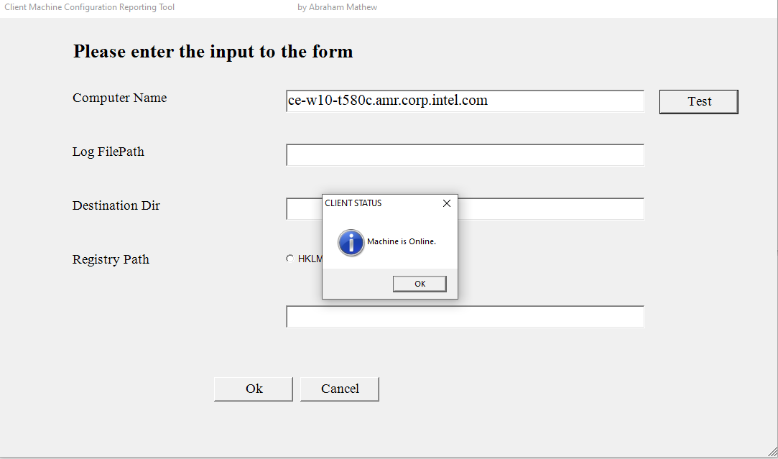

1. If Offline

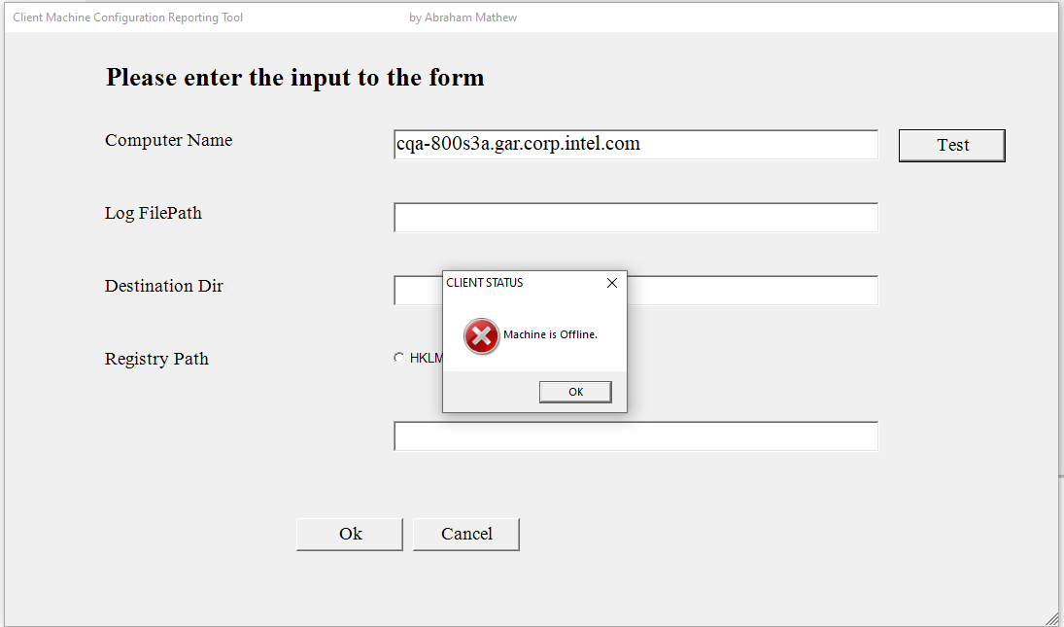

Note: You should mention the complete machine name with domain.corp.intel.com

1. Once you have checked machine is online. Its good to gather log and registry information from the machine. The tool lets you gather multiple log files.
2. Create a txt file with paths of log files you require. For ex:
3. 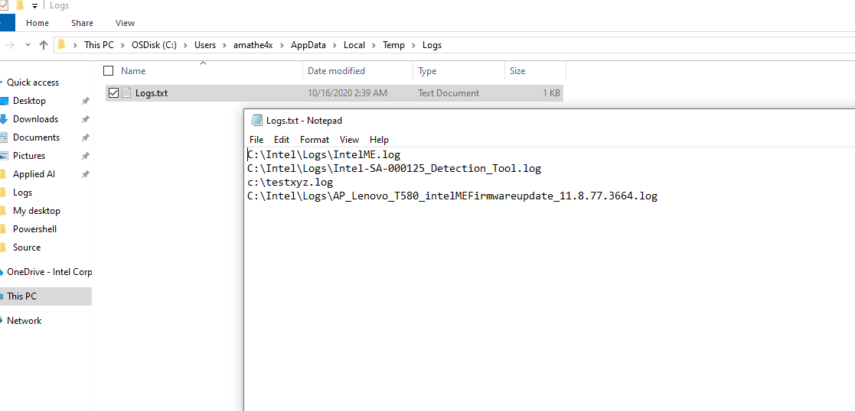

Input the full path of Logs.txt into the tool.

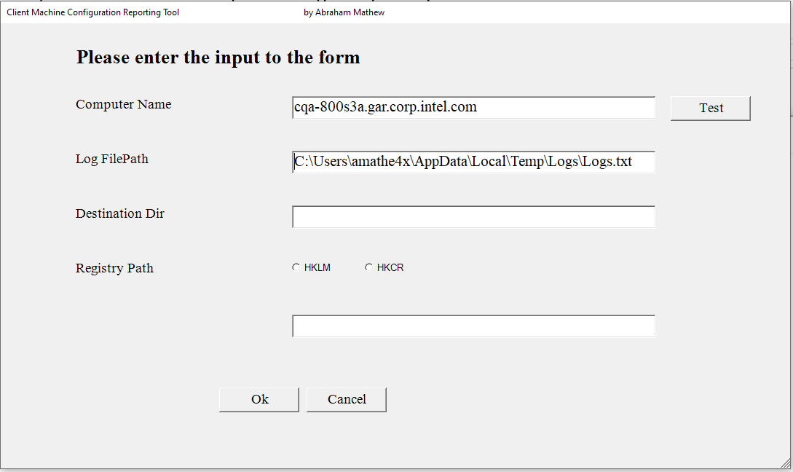

1. Enter the destination directory where you want to generate your output.

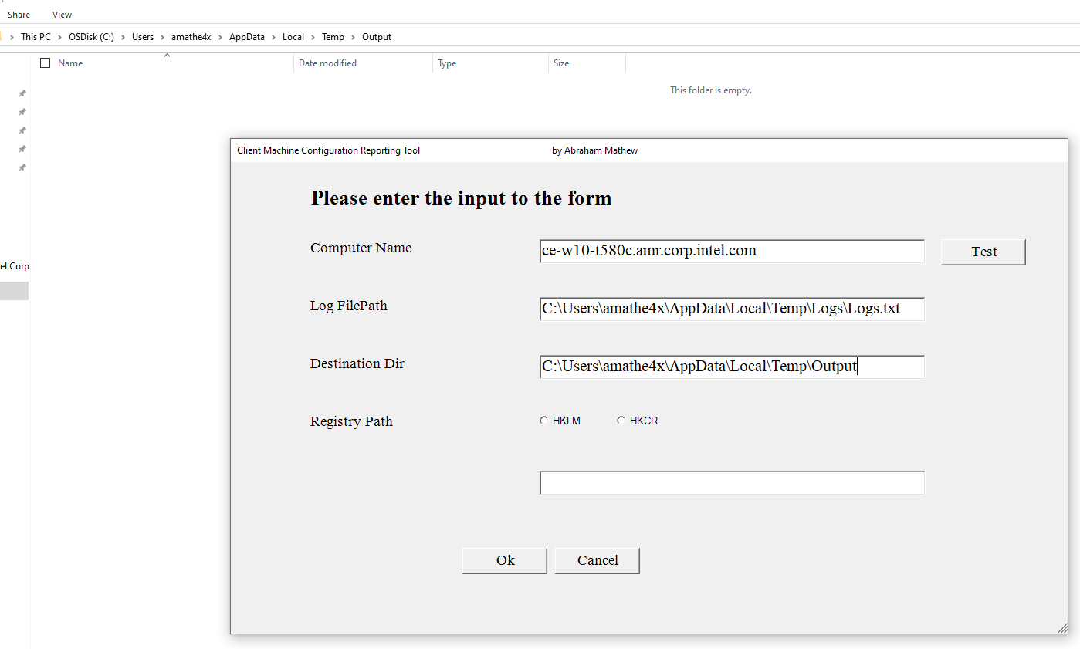

d)Based on your requirement you can select HKEY_LOCAL_MACHINE or KEY_CLASSES_ROOT registry hive. Enter the path as shown below.

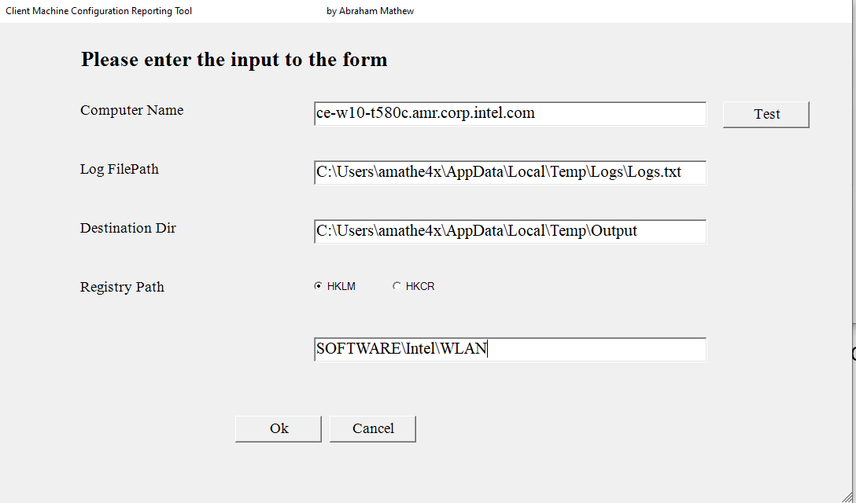

Note: You don’t need to mention root hive.

1. Click “OK”

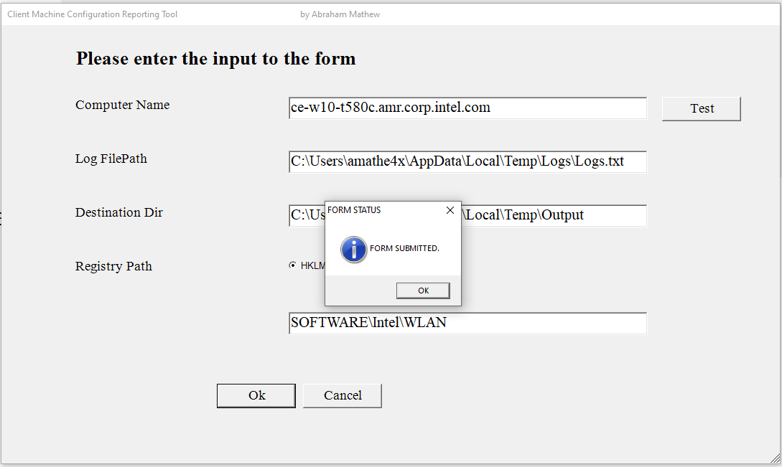

1. Click “Ok” to submit the form and wait for the execution to complete.

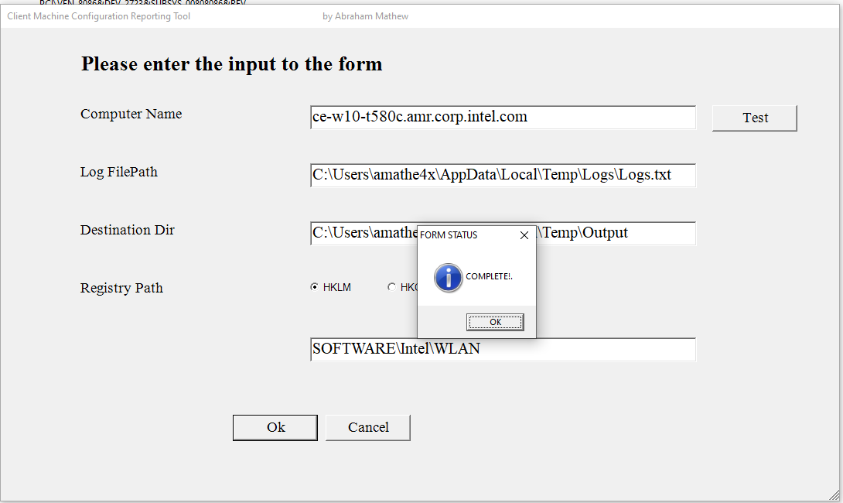

1. Click “OK” to complete status.

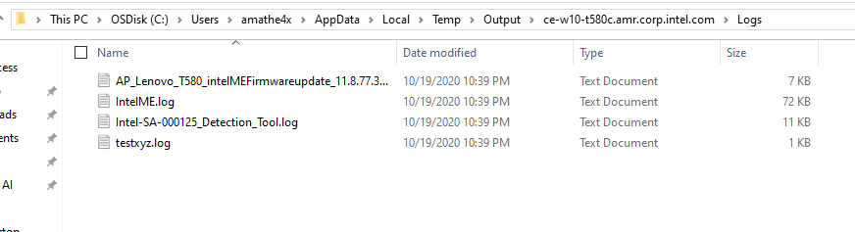

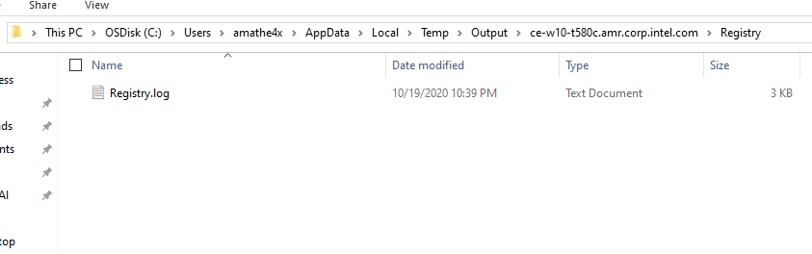

1. Now under destination dir you can see a folder with computer name. Inside this folder you can see all the log files and registry information from end user computer. It will extracts the sub registry keys as well.
2. Note: Computer name and Destination dir are Mandatory parameters
3. Now you can reuse the form by providing different input.

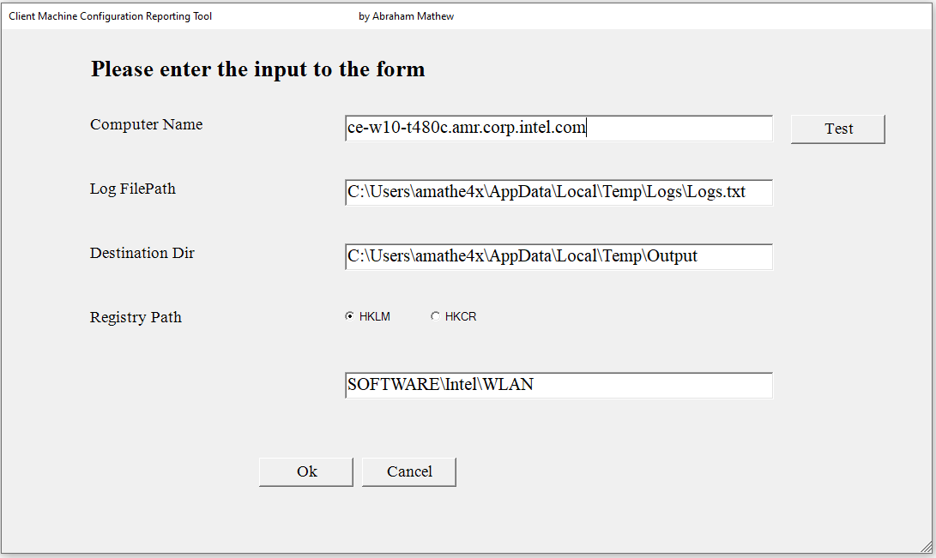

1. Close the tool by clicking “Cancel” button.